Unit 2-2 Combinations and Permutations

* Introduction to Counting
  + In this lesson, we'll discuss counting. You're thinking, "how silly, I learned this in elementary school," right? Understandable. But the kind of counting we'll discuss goes way beyond 1, 2, 3.
  + By applying our counting knowledge, we'll be able to answer questions like "How many different ways can we get a flush in poker?" or "What is the probability that a randomly selected five-person committee has more women than men if we pick the members from a group of 20 women and 30 men?"
  + Intrigued? Good, let's start counting!
* The Counting Principle
  + The counting principle — also known as the **fundamental theorem of counting** — states that if a job consists of k separate tasks and there are n1​ ways of doing the first task, n2​ ways of doing the second task, and so on, then there are *n1 * n2 * …nk*​ ways of completing the entire job.
  + Let's say we have three tasks to complete: Task A, Task B, and Task C. There are two ways to do Task A, three ways to do Task B, and six ways to do Task C.
    - The counting principle indicates that there are therefore 2×3×6=36 ways of accomplishing all three tasks.
* Factorial
  + One mathematical operation that is crucial for helping us with counting is the factorial.
  + We denote "n-factorial," or "the factorial of n," using the expression n!.
  + In other words, given some positive integer, n, we'll say that the factorial of n is given by:
    - *n*! = n * (n-1) * … 2 * 1
    - 2! = 2 * 1 = 2
    - 3! = 3 *2 *1 = 6
  + Although it may seem counterintuitive, we'll also define 0!=1. This protects us against dividing by zero in certain fringe cases.
  + Factorials are important to learn because n! is the number of ways to list a set of n objects.
  + This becomes important when calculating combinations and permutations, which we'll learn about later on. Without factorials, these equations can become long and tedious.
* Definitions
  + **Permutation**: An arrangement of objects without repetition in which **order matters**.
  + **Combination**: An arrangement of objects without repetition in which **order doesn't matter**.
* Permutations
  + So, a permutation is an arrangement of objects without repetition in which order matters. In the image below, each of the six rows is a different permutation of three distinct balls.
    - 
  + Permutations: Example 1
    - Say there are five qualified candidates to fill three roles: president, vice president, and secretary. How many ways can these roles be filled, assuming one person per position?
    - What information do we need to figure this out? What questions do we need to ask?
    - Let's say that we can't repeat people and we care about the order of our choices. This means we want to identify the number of permutations.
    - When calculating permutations, we care about two values: how many options there are (n) and how many options we want to choose (k). In this case, there are five options (five qualified candidates) and we are choosing three of them (filling three possible roles).
    - The formula for counting the number of permutations is given by  where n is the number of options and k is the number of options we want to choose.
    - Time for some math. How many ways can these roles be filled, assuming one person per position?
      * 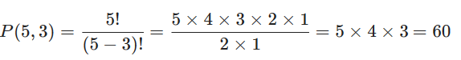
  + Permutations: Example 2
    - We have 10 different frozen meals in our fridge and plan to have one for lunch and one for dinner. How many ways can we choose a lunch and a dinner?
    - 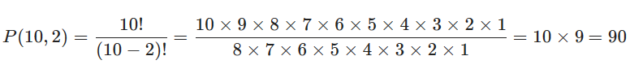
* Combinations
  + OK, let's take another quick peek at our key terms:
    - Permutation: An arrangement of objects without repetition in which order matters.
    - Combination: An arrangement of objects without repetition in which order doesn't matter.
  + Combinations are a meatier concept. In situations where order does not matter, we have to take into account all possible cases. Why is this?
  + Logically, we'll need to account for every variation. In other words, we'll need to look at every possible combination in every possible order. In the image below, we can see every combination of a three-element subset from a five-element set.
    - 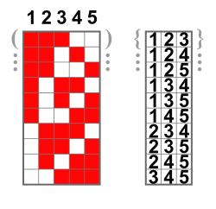
  + The formula for counting the number of combinations is given by
    - 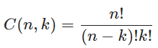
      * Where N is the number of options and K is the number of options we want to choose.
  + Combinations: Example 1
    - Let's walk through an example.
    - Say there are five qualified candidates to fill three identical roles. How many ways can these roles be filled, assuming one person per position?
    - In this case, because the roles are identical, our order does not matter.
    - With five qualified candidates to fill three identical roles (where order does not matter), assuming one person per position, we would express this as:
      * 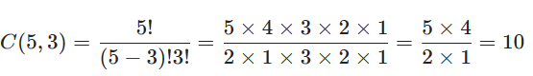
  + Combinations: Example 2
    - How many possible five-card hands are there within a deck of 52 cards?
    - 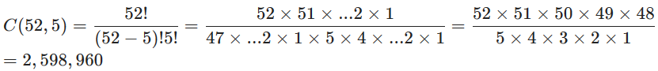
    - There are nearly 2.6 million possible five-card hands.
* Combining Combinations
  + Ready to take it to the next level? First, let's recall the counting principle:
    - The counting principle formally states that if a job consists of k separate tasks and there are n1​ ways of doing the first task, n2​ ways of doing the second task, and so on, then there are n1 * n2 * … nk​ ways of completing the entire job.
  + The Counting Principle
    - We can use our formula from the counting principle to break larger tasks into smaller ones. For example, let's say we have a group of university faculty members. Out of a total of 20 women and 30 men, how many committees of five people contain two men and three women?
      * How would we go about solving this?
        + The first secret is not to get overwhelmed! Instead, break the problem down into separate tasks. Here we can divide it into two groups: men and women.
        + Task 1: How many ways can we choose two men from 30? C(30,2)
        + Task 2: How many ways can we choose three women from 20? C(20,3)
        + Given the counting principle, we can multiply these two together to find how many committees contain two men and three women.



* From Combinations to Probability
  + Knowing there are 495,900 committees of five that contain two men and three women is a good start!
    - However, we're more interested in overall probabilities — in other words, we're interested in how likely it is that (given the totals above) a faculty committee will be composed of two men and three women.
    - What is the probability that a committee of five contains two men and three women out of a total of 20 women and 30 men?
    - Let's just divide our result by all possible combinations of committees — in this case, C(50,5).
    - 
      * Note: Here we write Prob() to differentiate probabilities from permutations
  + Let's walk through one more example of probability with combinations. What's the probability that a classroom of eight contains three undergraduates and five graduate students, out of a total of 15 undergraduates and 10 graduate students?
    - 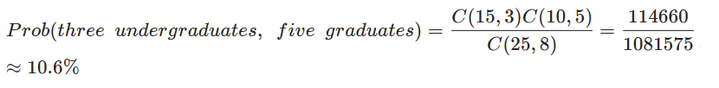
* But, What About Permutations?
  + We can extend the counting principle and our methods of determining probabilities to permutations as well — let's try it out!
  + What is the probability that — out of a total of 30 men and 20 women — a woman is selected as president and two men are selected to be vice president and secretary?
    - 